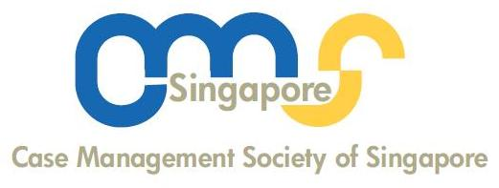
NOMINATION FORM

10th ANNUAL GENERAL MEETING
CASE MANAGEMENT SOCIETY OF SINGAPORE (CMSS)

The 10th Annual General Meeting (AGM) is to take place online via Zoom on 27 August 2021, Friday at 5pm. (link to be sent to members closer to the date)

The 10th CMSS’s Executive Council will be elected at the AGM for the next term, 2021 - 2023. Only CMSS’s members are eligible for voting.

The CMSS invites you to participate in the nomination of the Office Bearers and eight Executive Council Members for the new term. Nominations for the key office bearers are as follow:

- PRESIDENT
- VICE – PRESIDENT
- SECRETARY
- ASSISTANT SECRETARY
- TREASURER
- ASSISTANT TREASURER
- EXECUTIVE COUNCIL MEMBERS (8)

Officer Bearers | Name of Nominee  Institution | Name of Proposer  Institution | Name of Seconder  Institution
President

Vice-President

Secretary

Assistant Secretary

Treasurer

Assistant Treasurer

No | Name of Executive Council Members | Institution | Name of Proposer  Institution | Name of Seconder  Institution
1.
2.
3.
4.
5.
6.
7.
8.

Please email the completed nomination form to: admin@casemanagement.sg by 23 August 2021.

THANK YOU FOR YOUR SUPPORT

